[ Insert official UPAEP logo ]
UPAEP · Decanato de Ingenierías
EVIDENCE — US19-T9
Tune the detection parameters
SmartGreenAI: Cilantro Crop

1. Task information
Task ID | US19-T9
User Story | US-19 — Identify unusual environmental measurements
Sprint | Sprint 3 (2026-10-12 – 2026-10-30)
Week | Week 3
Responsible | Alexis Enrique Valle Parra
Peer reviewer | Jorge Velez Delgado
Planned / actual hours | 2 h / 2 h
Completed on | October 30, 2026
Status | Done

2. Task description
Using the false-positive rate measured in US19-T8 and the 7-day seed data, adjust the jump size, z-score and flatline time until the false-positive rate on normal data is below 5% while every injected anomaly is still detected. Document the final values.

Defect found while tuning (D-12)
The first tuning run (original code, 2026-10-30 22:23 UTC) showed that no flatline time could bring the periodic checks under 5 %: with the initial values the job flagged 62 of 376 sensor checks (16.489 %) on normal data. Two causes: the light sensor reads a constant 0 lux all night, which is darkness and not a frozen sensor, and an idle water tank keeps the same level for hours. Fix (anomalies service, runPeriodicChecks): FLATLINE is checked on light only during the daylight hours of the greenhouse (the same rule the alert engine already used), and the window can be set per sensor type (anomaly.flatline_minutes.<type>). The unit tests of US19-T7 cover both rules.
Periodic findings on normal data before the fix (initial values)
Sensor and method | Findings
WL-01 FLATLINE | 40
LUX-01 FLATLINE | 21
PH-01 FLATLINE | 1

server/src/modules/anomalies/service.js — lines 189–210
// --- 5. Flatline -------------------------------------------------------
// The window can be set per sensor type (anomaly.flatline_minutes.<type>,
// US19-T9): a water tank that nobody draws from keeps the same level for
// hours, so it needs a much longer window than a soil or air sensor.
// Darkness at night is a constant 0 lux by nature, so light is only
// checked during the daylight hours of the greenhouse.
const types = (await db.rows('SELECT DISTINCT type FROM sensors WHERE is_active')).map((r) => r.type);
const isDay = await daylight.isDaylight();
const windows = new Map();
for (const type of types) {
if (type === 'light' && !isDay) continue;
const minutes = await settings.getNumber(`anomaly.flatline_minutes.${type}`, FLATLINE_DEFAULTS[type] ?? flatlineMinutes);
if (!(minutes > 0)) continue;
windows.set(minutes, [...(windows.get(minutes) || []), type]);
}
for (const [minutes, windowTypes] of windows) {
const flat = await db.rows(
`SELECT s.id, s.name, s.unit,
stats.distinct_values, stats.n, stats.value
FROM sensors s
JOIN LATERAL (

3. Completion conditions
✓ Condition 1: False-positive rate below 5% on normal data.
How it was verified: False-positive rate below 5 % on normal data with the final set: 0.519 % of the readings at ingestion (12 of 2312, 24 h) and 0.658 % of the periodic sensor checks (2 of 304). Over 7 days of normal seed data (16136 readings replayed through the API): 0.235 %. Before: 1.514 % at ingestion in this run (5.49 % measured in US19-T8) and 11.17 % in the periodic checks. Method: fresh test database, seed-history model without faults, readings replayed in time order through POST /api/measurements; the periodic job evaluated every 30 minutes of the day.
Candidate parameter sets (24 h of normal data, same data for every set)
Set | z | Temp. jump | Flatline | Tank flatline | Ingestion FP | Periodic FP | Spike | Range | Outlier | Flat | Disc. | Target
A — initial values (US19-T1) | 3 | 5 °C | 30 min | 30 min | 1.514 % | 11.17 % | ✓ | ✓ | ✓ | ✓ | ✓ | —
B — z-score 3.5 | 3.5 | 5 °C | 30 min | 30 min | 0.519 % | 11.17 % | ✓ | ✓ | ✓ | ✓ | ✓ | —
C — z-score 4 | 4 | 5 °C | 30 min | 30 min | 0.346 % | 11.17 % | ✓ | ✓ | ✓ | ✓ | ✓ | —
D — B + temperature jump 3 °C | 3.5 | 3 °C | 30 min | 30 min | 0.519 % | 11.17 % | ✓ | ✓ | ✓ | ✓ | ✓ | —
E — B + flatline 15 min | 3.5 | 5 °C | 15 min | 15 min | 0.519 % | 14.323 % | ✓ | ✓ | ✓ | ✓ | ✓ | —
F — B + flatline 60 min | 3.5 | 5 °C | 60 min | 60 min | 0.519 % | 8.696 % | ✓ | ✓ | ✓ | ✓ | ✓ | —
G — B + tank flatline 120 min | 3.5 | 5 °C | 30 min | 120 min | 0.519 % | 5.682 % | ✓ | ✓ | ✓ | ✓ | ✓ | —
H — B + tank flatline 300 min | 3.5 | 5 °C | 30 min | 300 min | 0.519 % | 0.658 % | ✓ | ✓ | ✓ | ✓ | ✓ | MET
I — B + tank flatline 720 min | 3.5 | 5 °C | 30 min | 720 min | 0.519 % | 1.042 % | ✓ | ✓ | ✓ | ✓ | ✓ | MET

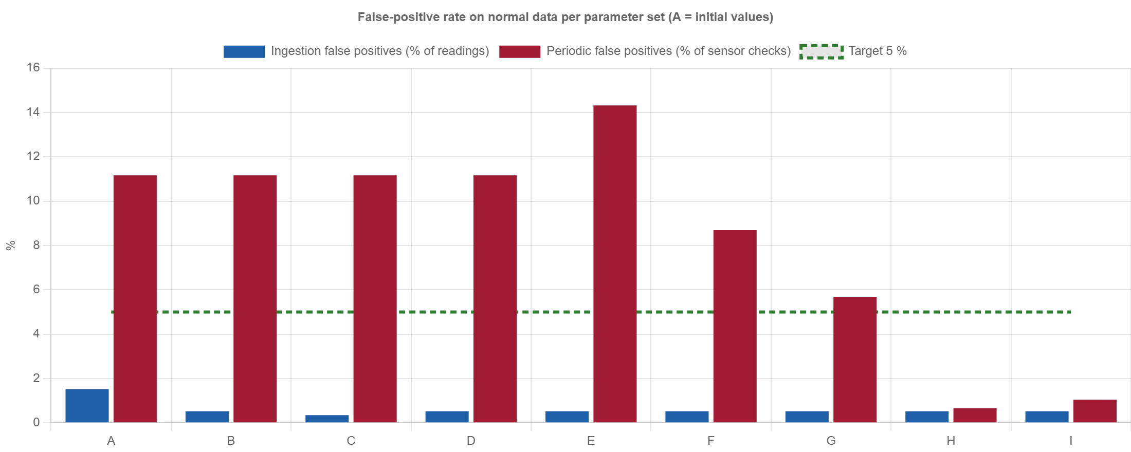
Figure US19-T9-1. False-positive rates of the candidate sets (data: attached JSON). (US19-T9_Tune_Detection_Parameters_3.png)
✓ Condition 2: Every injected anomaly is still detected.
How it was verified: Every injected anomaly is still detected with the final set (all five); set C (z-score 4) is rejected because the injected outlier sits at z ≈ 4 and has no margin.
Injected anomalies with the final set (H — B + tank flatline 300 min)
Anomaly (as in US19-T8) | Injection | Detected
Spike (sudden jump) | TMP-01 22 → 30 °C | ✓
Out-of-range value | SM-02 = 140 % | ✓
Outlier (z-score) | CO2-01 880 → 1 260 ppm (z = 4) | ✓
Flatline | HUM-01 frozen at 61 % for 40 min | ✓
Disconnection | SM-01 silent for 7 min | ✓

⚠ Condition 3 (pending team input): Final parameters approved by the team.
Pending: The team must approve the final values (z-score 3.5, tank flatline 300 min, the rest unchanged) at a meeting or in the team chat. Then add the approval record to tools/evidence/board_sprint3.js (APPROVAL["US19-T9"]) and rebuild this document.
How it was verified: Final parameters approved by the team.
Before / after (parameters stored in system_parameters)
Parameter | Before (US19-T1) | After (US19-T9) | Reason
anomaly.zscore_threshold | 3 | 3.5 | z-score > 3 caused all ingestion false positives (US19-T8: 127 = 5.49 %, night humidity, CO2, light); 3.5 removes two thirds of them and the injected outlier (z ≈ 4) is still found; 4 leaves no margin (the outlier sits at z ≈ 4.0).
anomaly.jump.temperature | 5 | 5 | No false positive with 5 °C; a tighter 3 °C finds the same spike and adds nothing, so the initial value is kept.
anomaly.jump.soil_moisture | 15 | 15 | No false positive with 15 %; kept.
anomaly.flatline_minutes | 30 | 30 | 15 min adds pH and soil flatlines on normal data, 60 min halves detection speed and still flags the tank; 30 min kept.
anomaly.flatline_minutes.water_level | 30 | 300 | New per-type window: a tank nobody draws from keeps the same level for hours (40 of 42 periodic false positives with the initial values). The shortest window that meets the target is kept.

Final values in the running database (5 rows; US19-T9_Tune_Detection_Parameters_4.csv)
key | value | description
anomaly.flatline_minutes | 30 | Minutes with an identical value that raise a FLATLINE ano…
anomaly.flatline_minutes.water_level | 300 | FLATLINE window of the water tank: an idle tank keeps its…
anomaly.jump.soil_moisture | 15 | Maximum % change in soil moisture between consecutive rea…
anomaly.jump.temperature | 5 | Maximum C change in temperature between consecutive readings
anomaly.zscore_threshold | 3.5 | Z-score above which a reading is a statistical outlier (2…
SQL: SELECT key, value, description FROM system_parameters WHERE key IN ('anomaly.zscore_threshold', 'anomaly.flatline_minutes', 'anomaly.flatline_minutes.water_level', 'anomaly.jump.temperature', 'anomaly.jump.soil_moisture') ORDER BY key
✓ Condition 4: Evidence: Before/after table of parameters and detection results.
How it was verified: Before/after table of parameters and detection results (US19-T9_Tune_Detection_Parameters_1.json, US19-T9_Tune_Detection_Parameters_2.json; script tools/evidence/tune_detection.js).

4. Attached files
- US19-T9_Tune_Detection_Parameters_1.json
- US19-T9_Tune_Detection_Parameters_2.json
- US19-T9_Tune_Detection_Parameters_3.png
- US19-T9_Tune_Detection_Parameters_4.csv
- US19-T9_Tune_Detection_Parameters_5.sql

5. Traceability
Related requirements | FR-27, NFR-08
Implementation | anomaly.zscore_threshold 3.5, anomaly.flatline_minutes.water_level 300, light FLATLINE only in daylight (system_parameters, anomalies svc)
Verification | tools/evidence/tune_detection.js (false positives on normal data + injected anomalies)

6. Sign-off
Role | Name | Date | Signature
Responsible | Alexis Enrique Valle Parra | October 30, 2026
Peer reviewer | Jorge Velez Delgado | October 30, 2026
Product Owner acceptance | Alexis Enrique Valle Parra | October 30, 2026
Approval record: Daily Meeting 3 of Sprint 3 (Monday, October 26, 2026), team update, Alexis Enrique Valle Parra (impediment): "The z-score check gives some false positives on night humidity; they will be measured in US19-T8 and tuned in US19-T9."

